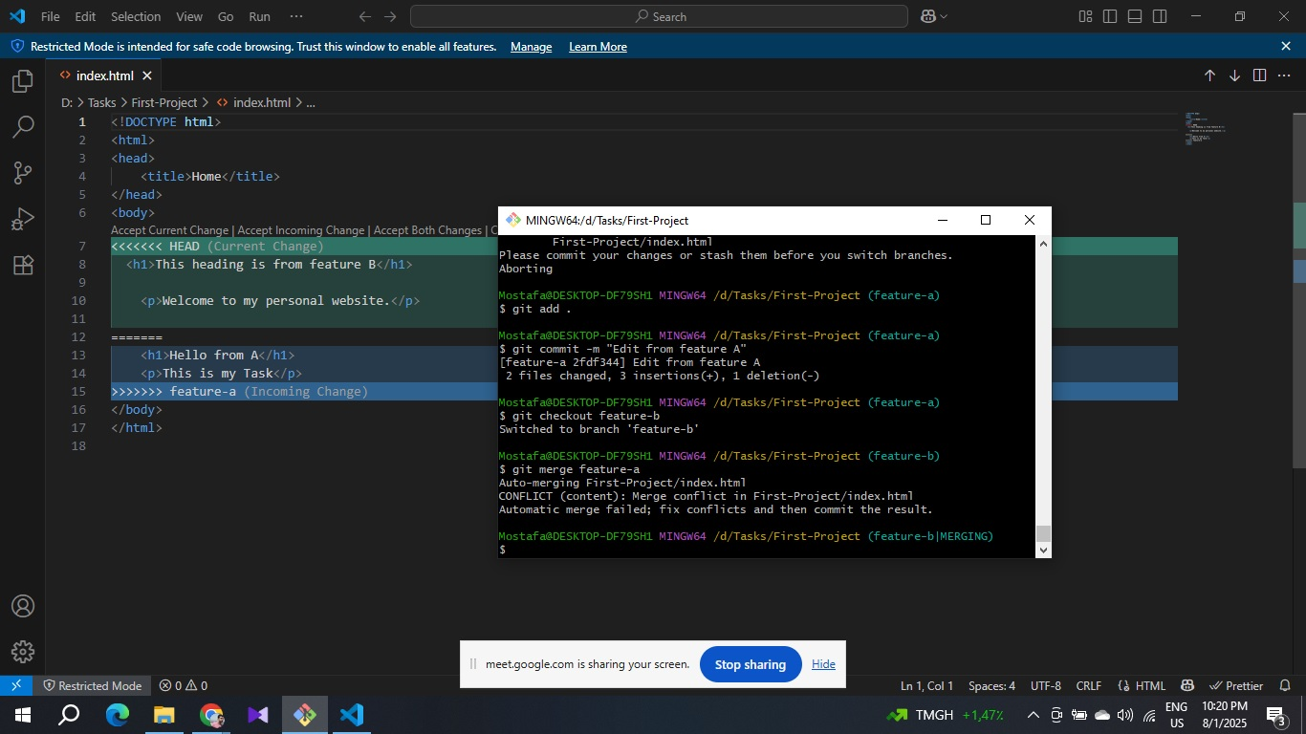

. A GitHub repository url : https://github.com/Mostafa161286/Tasks